Project Planning Phase

Project Planning Template (Product Backlog, Sprint Planning, Stories, Story Points)
Date | 19 September 2026
Team ID | Shaik Irshad - 238W1A4256
Project Name | Automated Network Request Management In ServiceNow
Maximum Marks | 5 Marks

Product Backlog, Sprint Schedule, and Estimation (4 Marks)
The product backlog below breaks the Network Request solution's functional epics into estimated user stories, sequenced across two sprints. All fourteen stories were delivered by the solo project team member.
Sprint | Functional Requirement (Epic) | User Story Number | User Story / Task | Story Points | Priority | Team Members
Sprint-1 | Network Request Submission | USN-1 | As a requester, I can open the Network Request catalog item from the Service Portal and enter my request details. | 2 | High | Shaik Irshad
Sprint-1 | Network Request Submission | USN-2 | As a requester, I cannot submit the request if a mandatory field is left blank. | 1 | High | Shaik Irshad
Sprint-1 | Network Request Submission | USN-3 | As a requester, I can select whether my connection is New or Existing. | 1 | High | Shaik Irshad
Sprint-1 | Dynamic Form Behaviour | USN-4 | As a requester, I only see the “Enter your Existing ID” field when I select Existing connection. | 2 | Medium | Shaik Irshad
Sprint-1 | Requester Info Auto-Population | USN-5 | As a requester, my email, name and phone number are filled in automatically once I set “Opened on behalf of”. | 2 | Medium | Shaik Irshad
Sprint-1 | Backend Configuration | USN-11 | As an admin, I can see all submitted network requests as structured records in one custom table. | 3 | Medium | Shaik Irshad
Sprint-2 | Email Notification | USN-6 | As a requester, I receive an email once my request has been created in the backend. | 2 | High | Shaik Irshad
Sprint-2 | Status Tracking & Traceability | USN-7 | As a requester, I can check whether my request is still pending or has been Approved/Rejected. | 2 | High | Shaik Irshad
Sprint-2 | Approval Workflow | USN-8 | As an approver, I receive an approval request when a new Network Request is submitted. | 1 | High | Shaik Irshad
Sprint-2 | Approval Workflow | USN-9 | As an approver, I can approve or reject a network request. | 2 | High | Shaik Irshad
Sprint-2 | Approval Workflow | USN-10 | As an approver, my decision automatically updates the request's final status. | 1 | High | Shaik Irshad
Sprint-2 | Backend Configuration | USN-12 | As an admin, I can trace an approval back to the request record it belongs to. | 2 | Medium | Shaik Irshad
Sprint-2 | Security & Access | USN-13 | As an admin, I want the new table to be secured without building a custom access framework. | 1 | Low | Shaik Irshad
Sprint-2 | Troubleshooting | USN-14 | As an admin, I can diagnose why a submission did not trigger the expected automation. | 2 | Medium | Shaik Irshad

Sprint Schedule:
Sprint | Total Story Points | Duration | Sprint Start Date | Sprint End Date (Planned) | Story Points Completed (as on Planned End Date) | Sprint Release Date (Actual)
Sprint-1 | 11 | 6 Days | 01 Aug 2026 | 06 Aug 2026 | 11 | 06 Aug 2026
Sprint-2 | 13 | 6 Days | 08 Aug 2026 | 13 Aug 2026 | 13 | 13 Aug 2026

Project Tracker, Velocity & Burndown Chart (4 Marks)
Velocity:
With a 6-day sprint duration and a combined velocity of 24 story points across the two sprints (12 days total), the team's average velocity (AV) per iteration unit (story points per day) is calculated as:
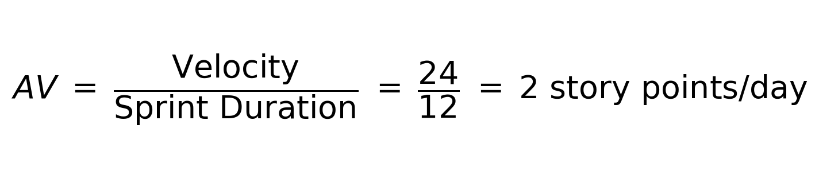
Burndown Chart:
A burndown chart plots work remaining against time. The two charts below track story points remaining, day by day, against the ideal straight-line pace for each of the project's sprints. Both sprints finished on schedule, with the team running slightly ahead of the ideal pace through the middle of each sprint.
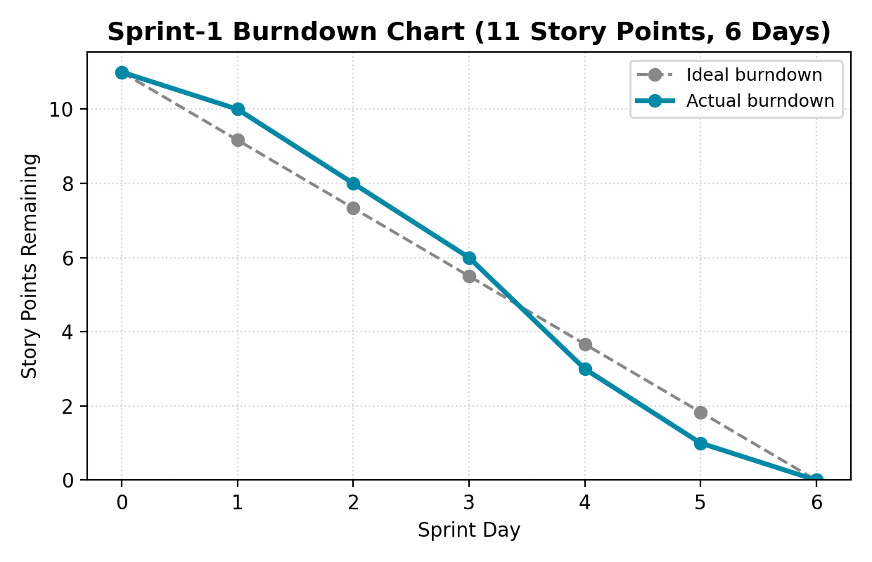

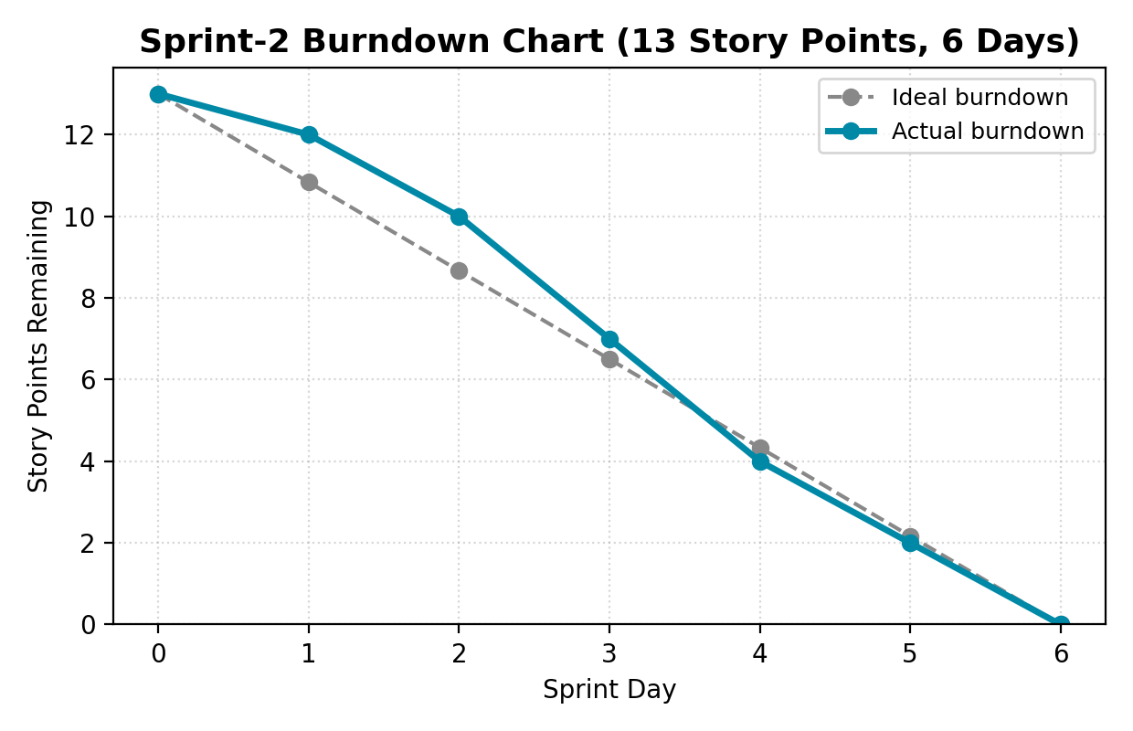
References:
https://www.atlassian.com/agile/project-management
https://www.atlassian.com/agile/tutorials/epics
https://www.atlassian.com/agile/tutorials/sprints
https://www.atlassian.com/agile/project-management/estimation
https://www.atlassian.com/agile/tutorials/burndown-charts

